Determination of the Ionization Constants of Weak Acids

Tayt Simpson, Conrad Matheu, Ricardo Lopez.

Lonestar College Kingwood.
20000 Kingwood Dr. Kingwood, TX 77339

___________________________________
ABSTRACT: For a weak acid solution that contains a salt of the acid, if the concentration of both the salt and the acid are reasonably large relative to the ionization that occurs, the Henderson-Hasselbach equation applies:

pH = pK_{a} + log([salt]/[acid])

Where pk_{a} = -log k_{a}

K_{a} = ionization constant for weak acid

[salt] = concentration in moles/L of salt of conjugate base of weak acid

[acid] = concentration in moles/L of weak acid

At the start, a solution of acetic acid contains no salt. If the acid is titrated with NaOH, the acid is gradually converted to NaC₂H₃O₂ and water so the concentration of acetate salt (conjugate base of acid) increases and acid concentration decreases. At the equivalence point all the acid has been reacted. This end point is readily observable as sudden large increase in pH.

At the point in the titration when enough NaOH has been added so exactly one half the equivalent amount of acid originally present has reacted, the concentration of [acid] = [salt] so the log [salt]/[acid] = log (1) = 0 and pH = pk_{a}.

Therefore, at the one-half equivalence point pH = pk_{a} and from this the k_{a} is calculated by taking the inverse log of the negative pk_{a} value.
___________________________________

Process
In this lab, accurately measured volumes of acetic acid of a known molarity will be titrated with a standard solution of NaOH to their respective equivalence point(s). Titration curves of pH versus volume of NaOH will be generated via a computer-based titration using a drop counter to determine volume and a pH probe to measure pH. Information from the curves will then be used to determine the K_{a} value as discussed above.

Run 1 Graph

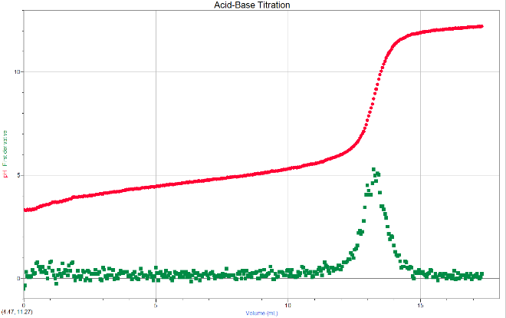

Run 2 Graph

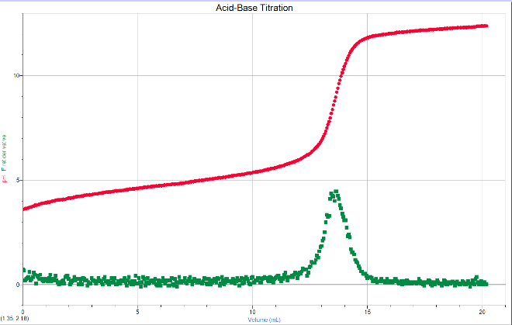

Run 1 Chart
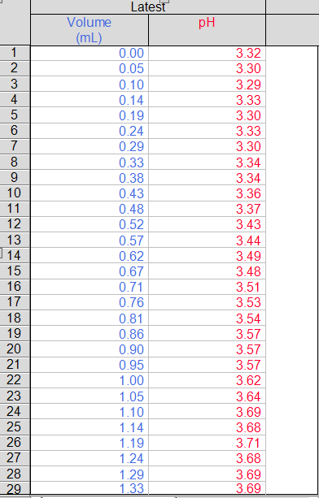

Run 2 Chart
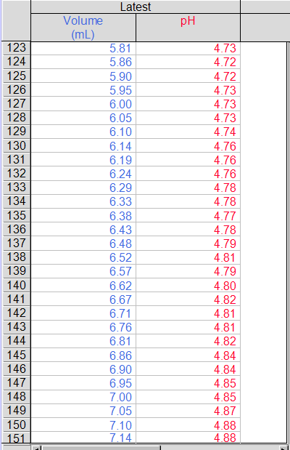

Data Sheet Determination of Ionization Constant
Acetic Acid (HC2H3O2) | Run 1 | Run 2
Volume (HC2H3O2) | 10ml | 10ml
Molarity (HC2H3O2) | 0.1M | 0.1M
Molarity (NaOH) | 0.1M | 0.1M

Volume NaOH at equiv. Point | 13.62 | 13,24
pH at equiv. point | 8.97 | 8.69

Volume at half equiv. point | 6.81 | 6.62
pH at half equiv. point | 4.82 | 4.72

pKa at half equiv. point | 4.82 | 4.72
Ionization at constant, Ka | 1.5E-5 | 1.9E-5

Average ka | 1.7E-5
% error | 5.56%
Drop counter calibration (drops/ml) | 210

$$pKa=-log⁡[K]$$
$$\left[A\right]=M=\frac{mols}{liters}$$
$$pH=pKa+log\frac{[A]}{\left[HA\right]}$$
$$K=\frac{\left[C\right]\left[D\right]}{\left[A\right]\left[B\right]}=Q$$
$$\% error=\frac{exp-given}{given}*100$$

In order to find the Ka at the half point of equilibrium we need to use the equation:
$$pH=pKa$$
We are given pH and to find ka from there we need to follow these steps.
$$pKa=-\log\left(Ka\right)$$
$${ka=e}^{-pH}$$
Now we plug in the numbers for Run 1 and Run 2.
$$1.5E-5=e^{-4.82}$$
$$1.9E-5=e^{-4.72}$$

Now that we have the ka for both run 1 and run 2 we need to find the average of the two.
$$\frac{1.5E-5+1.9E-5}{2}=1.7E-5$$
With the average we can find the Error percentage. Using the given ka of acetic acid and the equation below we can find the error percentage
$$\% error=\frac{1.7E-5-1.8E-5}{1.8E-5}*100=5.56\%$$

Post lab questions

- If, before any solution of NaOH, the measured pH is 2.87 for a 0.1M acetic acid solution calculate the Ka for acetic acid, Show calculations.

First we create a ICE chart
 | HA | H2O | <====> | A | H3O
I | .1 |  |  | 0 | 0
C | -x |  |  | +x | +x
E | 0.1-x |  |  | x | x
 | .09866 |  |  | .0013 | .0013

Then we find x using the given k value 1.8E-5
$$\frac{x^{2}}{.1-x}=1.8E-5(k)$$
$${√x}^{2}=√(1.8E-5*0.1)$$
$$x=1.3E-3$$
Now that we have x we can plug it into the ICE chart to find our new concentrations. These concentrations will be used In the equation below.
$$pH=pKa+log\frac{[A]}{\left[HA\right]}$$
$$pKa=-\log\left(Ka\right)$$
Now we fill in the numbers and calculate.
$$2.87=-logKa+log\frac{[.0013]}{\left[.09866\right]}$$
$$4.75=-logKa$$
$${ka=10}^{-4.75}$$
$$ka=1.778E-5=1.8E-5$$

- In the acetic acid experiment you recorded the pH and volume at the equivalence point.
What kind of solution do you have at the equivalence point?
The solution at its equivalent point is neutral.
Use your answer in part a to predict if the solution is will be acidic of basic.
I predict the solution to be basic. We are titrating an acid with a base. We will achieve the equivalence point and probably drop more base in than is required due to the nature of titration. This will cause the final solution to be more basic.

- Explain the reason for the result predicted in (b) using ionization equations and equilibrium concepts.

The solution at the equivalence point is a neutral solution by definition. We are titrating an acid with a base. We will achieve the equivalence point and probably drop more base in than is required due to the nature of titration. This caused the final solution to be more basic.

- How does the experimentally measured pH compare to your prediction?

It came out as per my prediction.

- In this experiment, we used the value of pH measured at the half equivalence point to determine the Ka value for the ionization using the equation pH = pKa at the half equivalence point. Starting with the Henderson-Hasselbach equation explain why this is correct.
$$pH=pKa+log\frac{[A]}{\left[HA\right]}$$
Looking at the table below we can see that [HA] and [A] are 2.5 which makes the equation
$$log\frac{[A]}{\left[HA\right]}=log\frac{[2.5]}{\left[2.5\right]}=0$$
Thus we can conclude that the equation$pH=pKa$ works just as well for half equilibrium

 | HA | NaOH | ====> | A
B | 5 | 2.5 = x |  | 0
C | -x | -x |  | +x
A | 2.5 | 0 |  | 2.5

ACKNOWLEDGMENT
This work was completed with data provided by Tayt Simpson, Conrad Matheu, Ricardo Lopez.

REFERENCES
Lonestar 1412 Chemistry lab manual

Steven S. Zumdahl, Susan A. Zumdahl, and Donald J. DeCoste. Chemistry 10th Edition. Cengage Learning, 2017.

